# Experiment 5.1

**Student Name: Aryan Srivastava UID: 22BCS13847**

**Branch: CSE Section: 22BCS_IOT-618/B**

**Semester: 6th DOP:21/02/25**

**Subject: PBLJ Subject Code:22CSH-359**

**Aim:** Write a Java program to calculate the sum of a list of integers using autoboxing and unboxing. Include methods to parse strings into their respective wrapper classes (e.g., Integer.parseInt()).

**Objective:** Demonstrate **autoboxing** and **unboxing** in Java by converting string numbers into Integer objects, storing them in a list, and computing their sum.

# Algorithm:

## Step 1: Initialize the Program

1. Start the program.
2. Import ArrayList and List classes.
3. Define the AutoboxingExample class.

## Step 2: Convert String Array to Integer List

1. Define the method parseStringArrayToIntegers(String[] strings).
2. Create an empty ArrayList<Integer>.
3. Iterate through the string array:
   * Convert each string to an Integer using Integer.parseInt(str).
   * Add the integer to the list (**autoboxing** happens here).
4. Return the list of integers.

## Step 3: Calculate the Sum of Integers

1. Define the method calculateSum(List<Integer> numbers).
2. Initialize a variable sum to 0.
3. Iterate through the list:
   * Extract each integer (**unboxing** happens here).
   * Add it to sum.
4. Return the total sum.

## Step 4: Execute Main Function

1. Define main(String[] args).
2. Create a string array with numeric values.
3. Call parseStringArrayToIntegers() to convert it into a list of integers.
4. Call calculateSum() to compute the sum.
5. Print the result.

## Step 5: Terminate the Program

1. End the execution.

# Code:

import java.util.ArrayList; // Importing ArrayList to store integers  
import java.util.List; // Importing List interface for flexibility  
import java.util.Scanner; // Importing Scanner for user input  
  
public class IntegerSumCalculator {  
  
 // Method to parse a string into an Integer  
 public static Integer parseStringToInteger(String str) {  
 try {  
 return Integer.parseInt(str); // Converts string to Integer (Autoboxing happens here)  
 } catch (NumberFormatException e) { // Handles invalid inputs that cannot be converted  
 System.out.println("Invalid number format: " + str);  
 return null; // Return null for invalid input  
 }  
 }  
  
 // Method to calculate the sum of a list of Integers  
 public static int calculateSum(List<Integer> numbers) {  
 int sum = 0; // Variable to store the sum  
 for (Integer num : numbers) { // Iterates through the list  
 if (num != null) { // Ensures null values are ignored  
 sum += num; // Adds the value to sum (Unboxing happens here)  
 }  
 }  
 return sum; // Returns the total sum  
 }  
  
 public static void main(String[] args) {  
 Scanner scanner = new Scanner(System.in); // Creating Scanner object to take input  
 List<Integer> numbers = new ArrayList<>(); // List to store integer inputs  
  
 System.out.println("Enter numbers (type 'done' to finish):");  
  
 while (true) { // Infinite loop until 'done' is entered  
 String input = scanner.nextLine(); // Reads user input as a string  
 if (input.equalsIgnoreCase("done")) { // Checks if user wants to stop  
 break; // Exit loop  
 }  
 Integer number = parseStringToInteger(input); // Converts input to Integer  
 if (number != null) { // Adds only valid numbers to the list  
 numbers.add(number); // Autoboxing: Converts int to Integer automatically  
 }  
 }  
  
 scanner.close(); // Closing the scanner to prevent memory leaks  
  
 // Calculating and displaying the sum of valid numbers entered  
 System.out.println("The sum of the list is: " + calculateSum(numbers));  
 }  
}

# Output:

**Test case 1:**

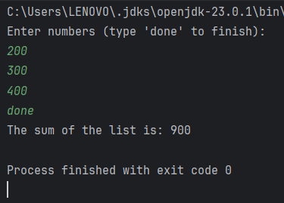

**Test case 2:**

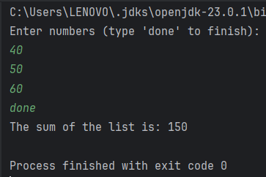

**Test case 3:**

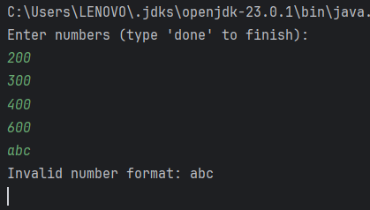

* **Learning Outcomes:**
* Understand the concept of **autoboxing and unboxing** in Java and how primitive types are automatically converted to their wrapper classes and vice versa.
* Learn how to **convert string values into Integer objects** using Integer.parseInt() and store them in a list.
* Gain experience in **working with ArrayLists** to store and manipulate a collection of numbers dynamically.
* Develop proficiency in **iterating through collections** and performing arithmetic operations like summation.

# Experiment 5.2

1. **Aim:** Create a Java program to serialize and deserialize a Student object. The program should:
   * Serialize a Student object (containing id, name, and GPA) and save it to a file.
   * Deserialize the object from the file and display the student details.
   * Handle FileNotFoundException, IOException, and ClassNotFoundException using exception handling.
2. **Objective:** The objective is to serialize and deserialize a Student object, store and retrieve its id, name, and GPA from a file, and handle exceptions like FileNotFoundException, IOException, and ClassNotFoundException.
3. **Algorithm:**

Step 1: Initialize the Program

1. Start the program.
2. Import the necessary classes (java.io.*).
3. Define a Student class implementing Serializable.
4. Declare attributes:
   * id (int)
   * name (String)
   * gpa (double)
5. Define a constructor to initialize Student objects.
6. Override toString() to display student details. Step 2: Define the Serialization Method
7. Create serializeStudent(Student student).
8. Use a try-with-resources block to create an ObjectOutputStream:
   * Open a FileOutputStream to write to student.ser.
   * Write the Student object to the file using writeObject().
9. Handle exceptions:
   * FileNotFoundException → Print error message.
   * IOException → Print error message.
10. Print a success message if serialization is successful. Step 3: Define the Deserialization Method
11. Create deserializeStudent().
12. Use a try-with-resources block to create an ObjectInputStream:
    * Open a FileInputStream to read student.ser.
    * Read the Student object using readObject().
13. Handle exceptions:
    * FileNotFoundException → Print error message.
    * IOException → Print error message.
    * ClassNotFoundException → Print error message.
14. Print the deserialized student details. Step 4: Execute Main Function
15. Define main(String[] args).
16. Create a Student object with sample data.
17. Call serializeStudent() to save the object.
18. Call deserializeStudent() to read and display the object.
19. Step 5: Terminate the Program
20. End execution.
21. **Implementation Code:**

import java.io.*; // Importing required classes for serialization and file handling //Exp 5.2

import java.util.Scanner; // Importing Scanner class for user input

// Student class implementing Serializable to enable object serialization

class Student implements Serializable {

private static final long serialVersionUID = 1L; // Recommended to ensure compatibility during deserialization

// Private fields to store student details

private int id;

private String name;

private double gpa;

// Constructor to initialize Student object

public Student(int id, String name, double gpa) {

this.id = id;

this.name = name;

this.gpa = gpa;

}

// Method to display student details

public void display() {

System.out.println("Student ID: " + id + ", Name: " + name + ", GPA: " + gpa);

}

}

// Main class for serialization and deserialization

public class StudentSerialization {

private static final String FILE_NAME = "student.ser"; // File where the student object will be saved

// Method to serialize Student object to file

public static void serializeStudent(Student student) {

try (ObjectOutputStream oos = new ObjectOutputStream(new FileOutputStream(FILE_NAME))) {

oos.writeObject(student); // Writing student object to file

System.out.println("Student object has been serialized and saved to file.");

} catch (IOException e) { // Handling possible I/O exceptions

System.out.println("Error during serialization: " + e.getMessage());

}

}

// Method to deserialize Student object from file

public static Student deserializeStudent() {

try (ObjectInputStream ois = new ObjectInputStream(new FileInputStream(FILE_NAME))) {

return (Student) ois.readObject(); // Reading object from file and casting it back to Student

} catch (FileNotFoundException e) { // Handling file not found exception

System.out.println("Error: File not found.");

} catch (IOException e) { // Handling input/output errors

System.out.println("Error during deserialization: " + e.getMessage());

} catch (ClassNotFoundException e) { // Handling case where class is not found

System.out.println("Error: Class not found.");

}

return null; // Return null if deserialization fails

}

public static void main(String[] args) {

Scanner scanner = new Scanner(System.in); // Scanner object to take user input

// Taking user input for Student details

System.out.print("Enter Student ID: ");

int id = scanner.nextInt(); // Reading integer input for student ID

scanner.nextLine(); // Consuming the newline left after nextInt()

System.out.print("Enter Student Name: ");

String name = scanner.nextLine(); // Reading student name as a string

System.out.print("Enter Student GPA: ");

double gpa = scanner.nextDouble(); // Reading double input for GPA

// Creating a Student object with the provided details

Student student = new Student(id, name, gpa);

// Calling method to serialize (save) the Student object to a file

serializeStudent(student);

// Calling method to deserialize (read) the Student object from the file

Student deserializedStudent = deserializeStudent();

// If deserialization was successful, display the student details

if (deserializedStudent != null) {

System.out.println("Student object has been deserialized.");

System.out.println("Deserialized Student Details:");

deserializedStudent.display(); // Calling display method of the deserialized object

}

scanner.close(); // Closing scanner to prevent memory leaks

}

}

1. **Output**

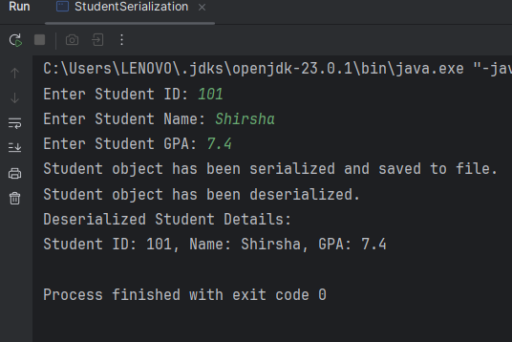

1. **Learning Outcomes:**
   * Understand object serialization and deserialization in Java.
   * Learn how to use ObjectOutputStream and ObjectInputStream for file operations.
   * Implement exception handling for FileNotFoundException, IOException, and ClassNotFoundException.
   * Gain hands-on experience in storing and retrieving objects from a file.
   * Develop skills in data persistence and file management using Java.

# Experiment 5.3

1. **Aim:** Create a menu-based Java application with the following options.
   1. Add an Employee
   2. Display All
   3. Exit If option 1 is selected, the application should gather details of the employee like employee name, employee id, designation and salary and store it in a file. If option 2 is selected, the application should display all the employee details. If option 3 is selected the application should exit.
2. **Objective:** The objective is to develop a menu-based Java application that allows users to **add employee details**, **store them in a file**, and **display all stored employee records**, with an option to exit the program.

## Algorithm:

1. Start
2. Display Menu:

* Add an Employee
* Display All Employees
* Exit

1. **Repeat Until User Selects Exit:**

* **If user selects option 1 (Add an Employee):**
* Prompt user to enter Employee Name, Employee ID, Designation, and Salary.

1. Store the details in an Employee object.
2. Append the Employee object to a file.
3. **If user selects option 2 (Display All Employees):**

Read employee details from the file.

Display all stored employee records.

1. **If user selects option 3 (Exit):**

Terminate the program.

**Else:**

Display an "Invalid option" message.

1. **End**
2. **Implementation Code:**

import java.io.*; // Importing necessary classes for file handling and serialization //Exp 5.3

import java.util.*; // Importing utility classes, including List and Scanner

// Employee class implementing Serializable to allow object serialization

class Employee implements Serializable {

private static final long serialVersionUID = 1L; // Ensures compatibility during deserialization

// Private fields to store employee details

private int id;

private String name;

private String designation;

private double salary;

// Constructor to initialize Employee object

public Employee(int id, String name, String designation, double salary) {

this.id = id;

this.name = name;

this.designation = designation;

this.salary = salary;

}

// Method to display employee details

public void display() {

System.out.println("Employee ID: " + id + ", Name: " + name + ", Designation: " + designation + ", Salary: " + salary);

}

}

// Main class for employee management system

public class EmployeeManagement {

private static final String FILE_NAME = "employees.ser"; // File where employee objects will be stored

private static final Scanner scanner = new Scanner(System.in); // Scanner object for user input

// Method to add a new employee and save it to file

public static void addEmployee() {

System.out.print("Enter Employee ID: ");

int id = scanner.nextInt(); // Read employee ID

scanner.nextLine(); // Consume the newline character left by nextInt()

System.out.print("Enter Employee Name: ");

String name = scanner.nextLine(); // Read employee name

System.out.print("Enter Designation: ");

String designation = scanner.nextLine(); // Read employee designation

System.out.print("Enter Salary: ");

double salary = scanner.nextDouble(); // Read employee salary

// Creating an Employee object with user input

Employee employee = new Employee(id, name, designation, salary);

// Save the employee object to the file

saveEmployeeToFile(employee);

System.out.println("Employee added successfully!");

}

// Method to save an employee object to file using serialization

public static void saveEmployeeToFile(Employee employee) {

List<Employee> employees = readEmployeesFromFile(); // Read existing employees from file

employees.add(employee); // Add the new employee to the list

// Serialize the updated list of employees and save it to the file

try (ObjectOutputStream oos = new ObjectOutputStream(new FileOutputStream(FILE_NAME))) {

oos.writeObject(employees); // Writing the list of employees to the file

} catch (IOException e) {

e.printStackTrace(); // Print error details for debugging

}

}

// Method to display all employees stored in the file

public static void displayAllEmployees() {

List<Employee> employees = readEmployeesFromFile(); // Retrieve list of employees from file

if (employees.isEmpty()) { // Check if there are no employees

System.out.println("No employees found.");

} else {

for (Employee emp : employees) { // Loop through the list and display each employee

emp.display();

}

}

}

// Method to read the list of employees from the file

@SuppressWarnings("unchecked") // Suppresses unchecked cast warning

public static List<Employee> readEmployeesFromFile() {

List<Employee> employees = new ArrayList<>(); // Initialize an empty list to store employees

try (ObjectInputStream ois = new ObjectInputStream(new FileInputStream(FILE_NAME))) {

employees = (List<Employee>) ois.readObject(); // Read and cast object from file

} catch (FileNotFoundException e) {

// If file not found, no action needed (first run scenario)

} catch (IOException | ClassNotFoundException e) {

e.printStackTrace(); // Print error details for debugging

}

return employees; // Return the list of employees

}

// Main method to display menu and handle user choices

public static void main(String[] args) {

while (true) { // Infinite loop for menu until user chooses to exit

System.out.println("\nMenu:");

System.out.println("1. Add Employee");

System.out.println("2. Display All Employees");

System.out.println("3. Exit");

System.out.print("Enter your choice: ");

int choice = scanner.nextInt(); // Read user choice

switch (choice) {

case 1:

addEmployee(); // Call method to add employee

break;

case 2:

displayAllEmployees(); // Call method to display employees

break;

case 3:

System.out.println("Exiting program...");

scanner.close(); // Close scanner before exiting

return; // Exit program

default:

System.out.println("Invalid choice. Please try again."); // Handle invalid input

}

}

}

**5.Output:**

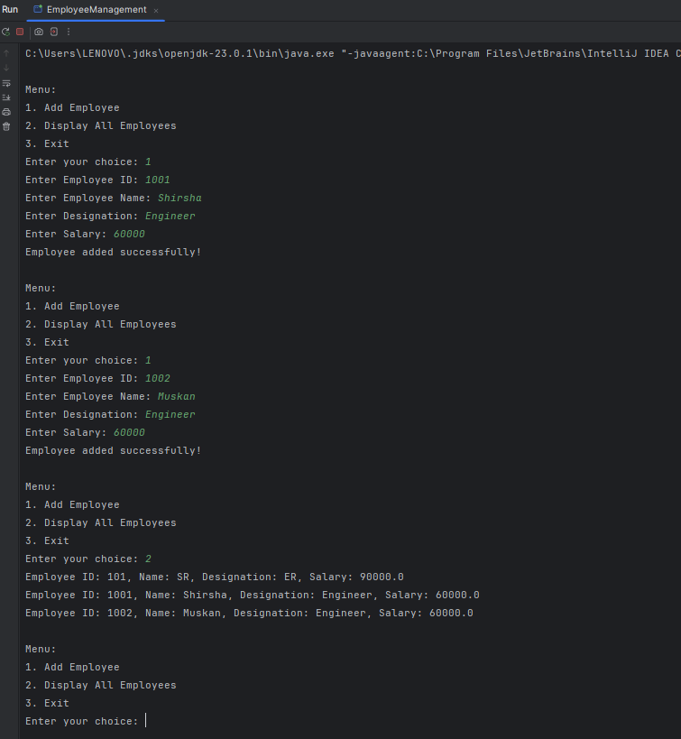

**6.Learning Outcomes:**

* Understand file handling and serialization in Java to store and retrieve objects persistently.
* Learn how to implement a menu-driven console application using loops and conditional statements.
* Gain experience in object-oriented programming (OOP) by defining and managing Employee objects.
* Practice exception handling to manage file-related errors like FileNotFoundException and IOException.
* Develop skills in list manipulation and user input handling using ArrayList and Scanner.